**TASK** - To Build a Battle Station App using Salesforce Trailhead.

1. To create the Battle Station Construction App

**DESCRIPTION** : In this project, you will learn how to build an application on the Salesforce Platform from start to finish, You will build a super-awesome project management app that allows users to manage the resources and supplies used to build a Battle Station. In this particular task we create the Battle Station Construction app the object and the particular elements regarding the app.

**PROCEDURE** :

1.First Open the Trailhead account and switch to Battle station Project and open the first module and Launch the Playground.

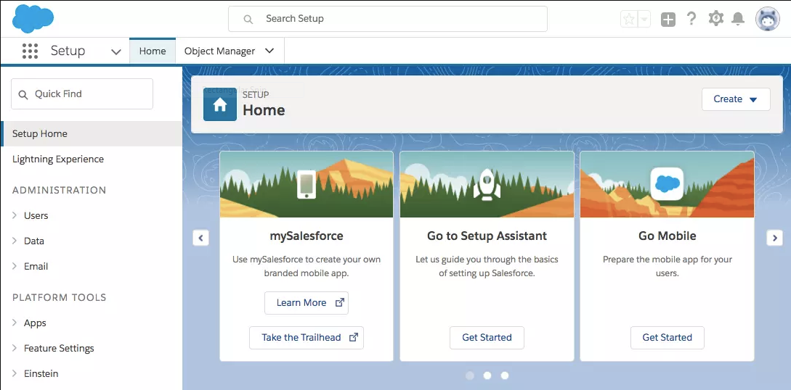

2.In the Trailhead Playground open the setup by clicking the setting.png icon at the top .

Before creating the Construction app we need to create an object BattleStation.

**i)Create the Battle Station Object**

1. Click on the Object Manager tab next to the Home tab.

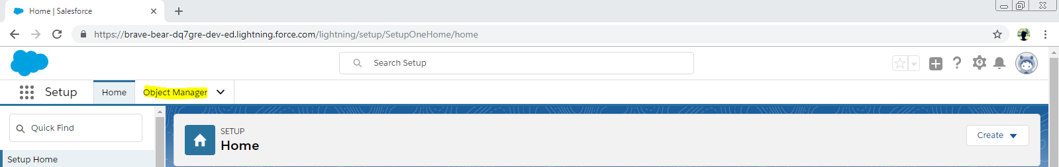

2. Now click on Create dropdown at the right side and then select Custom Object.

3.On the Custom Object Page Create the Object as Follows

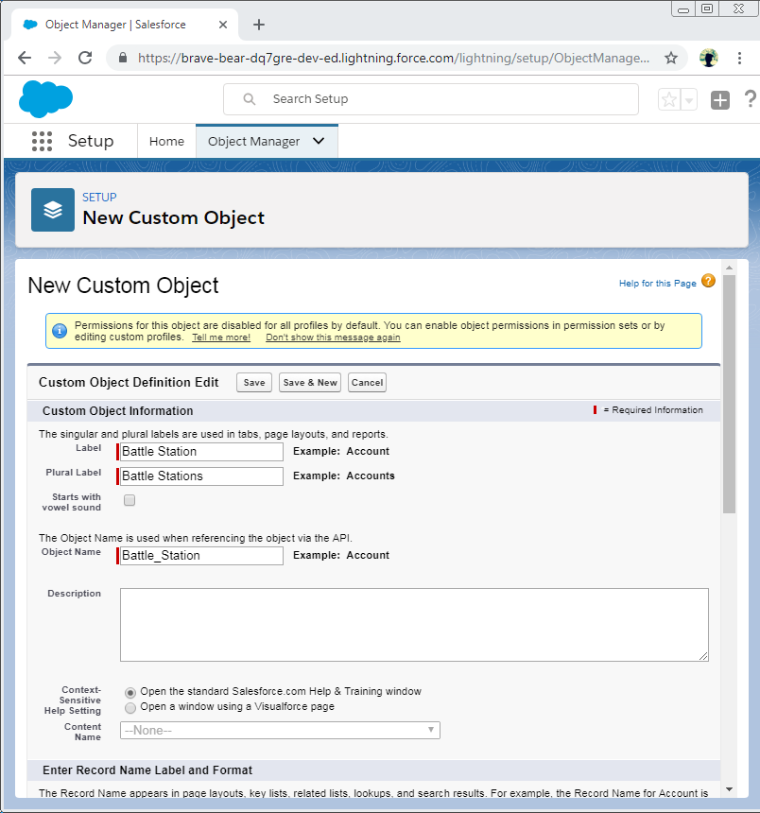

4.After Entering the Label and Record Names Now Check the Allow Reports and Allow Search checkboxes at the bottom and save the object.

5.Now let us create a Custom tab, Click Home tab enter Tabs in Quick Find and select Tabs.

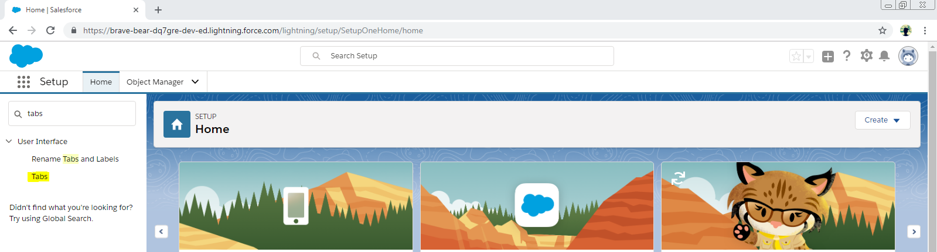

6. Under Custom Object Tabs click New.

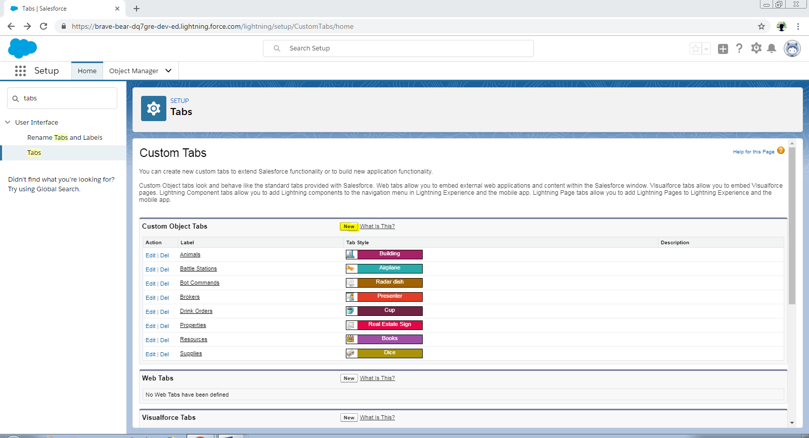

7. Now for object Select Battle Station and select any icon for the tab style leaving all the defaults as it is, Click Next -> Next and Save.

8. Now we need to enable Feed Tracking for the Battle Station Object.

Enter **Feed in QuickFind** -> Select **Feed Tracking .**

Click on Battle Station App -> Check **Enable Feed Tracking** checkbox -> Check the **Battle Station Name** and **Owner** Checkboxes and save.

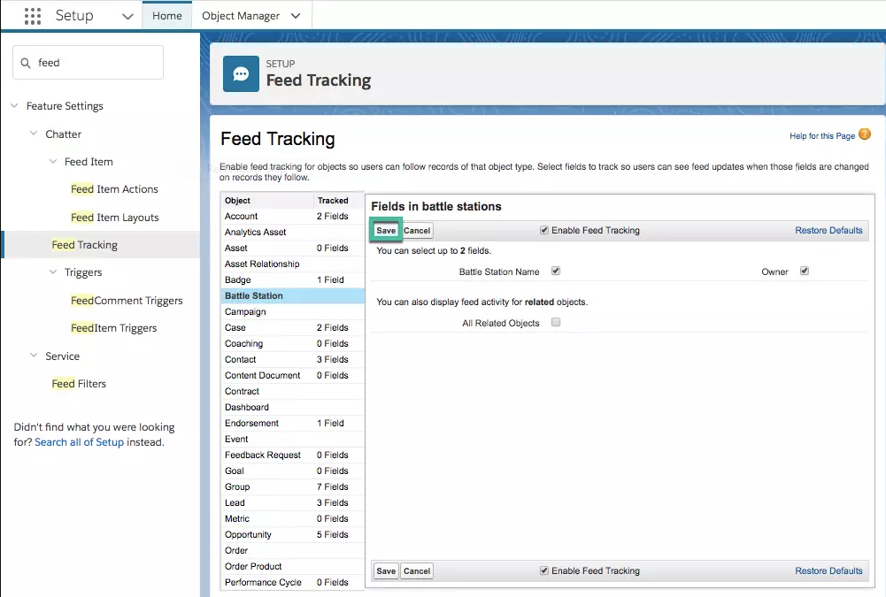

**ii)Create the Battle Station Construction App**

First enter App Manager in the Quick Find from the setup and select it.

1. Click New Lightning App. Enter Battle Station Construction as the App Name, then click Next.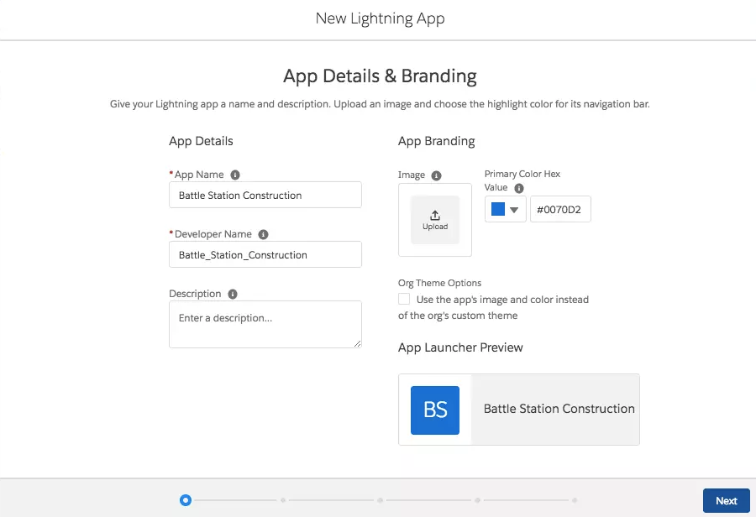
2. Leave Standard Navigation Selected and click next and next.
3. From Available Items ,select Battle Stations, Reports, and Dashboards and move them to Selected Items. Click Next.

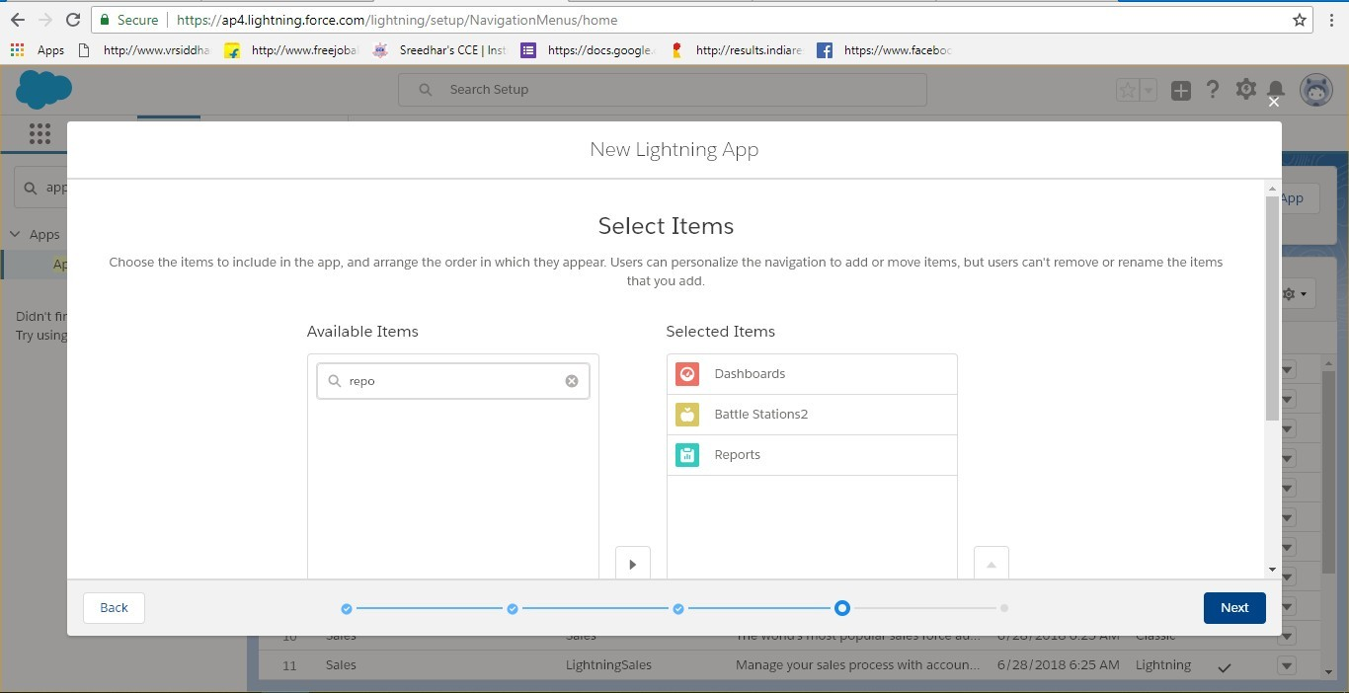

1. From Available Profiles select System Administrator and move it to Selected Profiles. Click Save and Finish.
2. To verify the changes Click the se.png App launcher and select Battle Station Construction app.

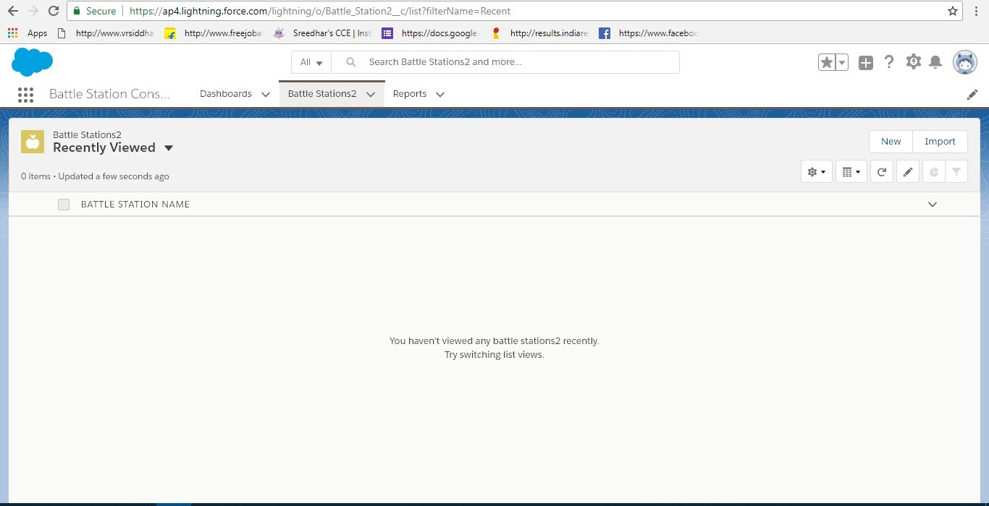

**RESULT :** Thus we created a Battle Station Construction app Successfully.

**b)AIM** : To Build an Object Model for the Battle Station App.

**DESCRIPTION** : Now we create the Master-Detail Relationship among the three Custom objects namely Battle Station, Resource and Supply. Custom Objects—These are new objects you create to store information unique to your application. Custom objects extend the functionality that standard objects provide. For our Battle Station Construction app we'll be using Custom Objects exclusively.Here Battle Station is the main object that which tracks the status of the project.

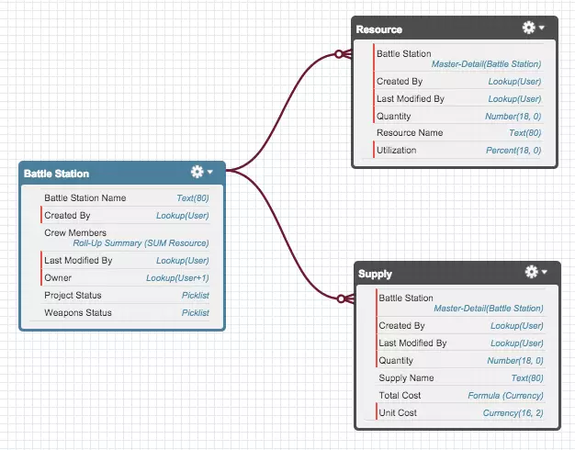

**PROCEDURE :**

In this task we create a Battle Station Custom Object.

First Click setting.png and select **Setup** -> **Click Object Manager** tab next to Home -> Select **Battle Station** -> Select **Fields & Relationships** from the left navigation, and click **New.**

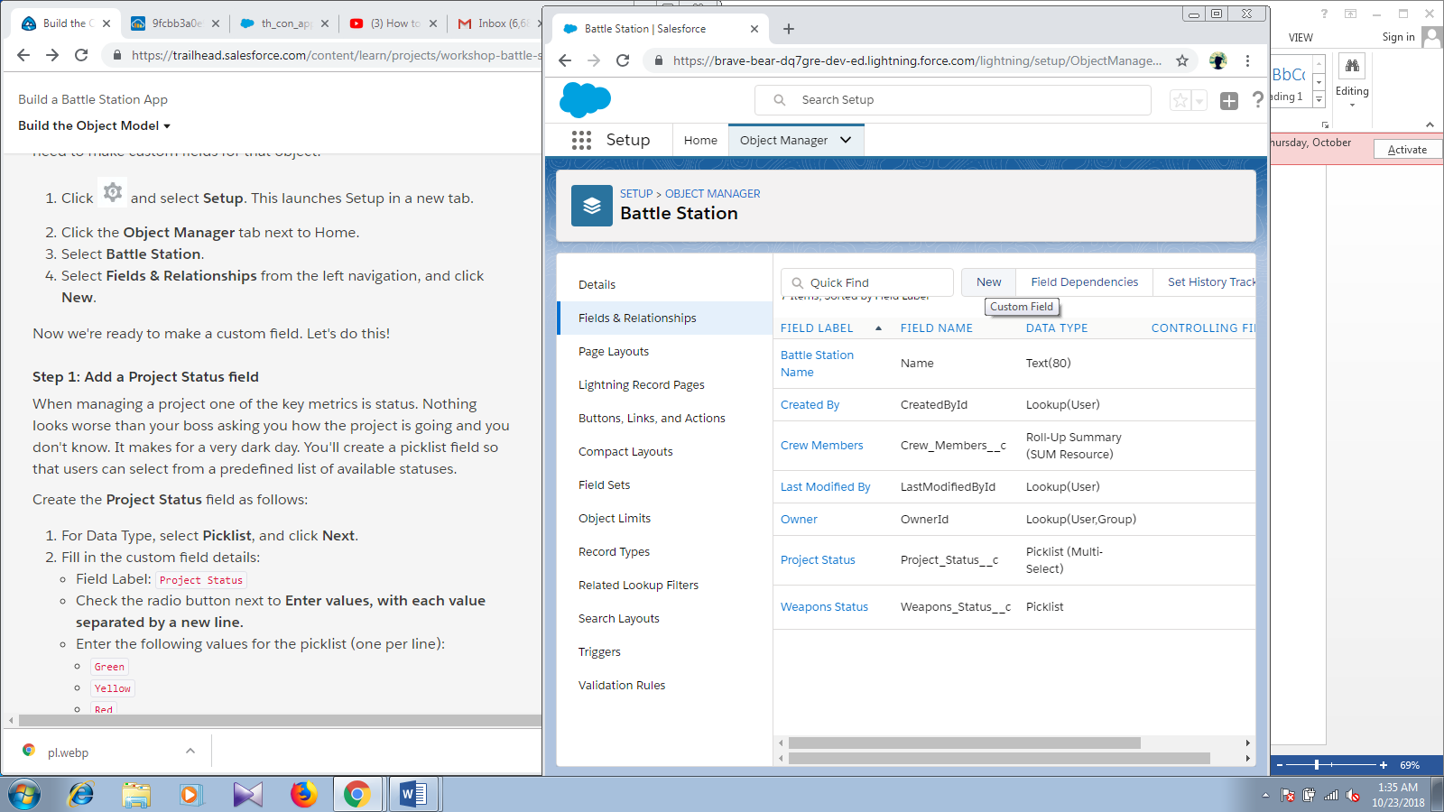

Now we add custom fields to that object.

1. **Add a Project Status Field**

After Clicking the New Select **Picklist** and click **Next**

Fill the custom field details as follows :

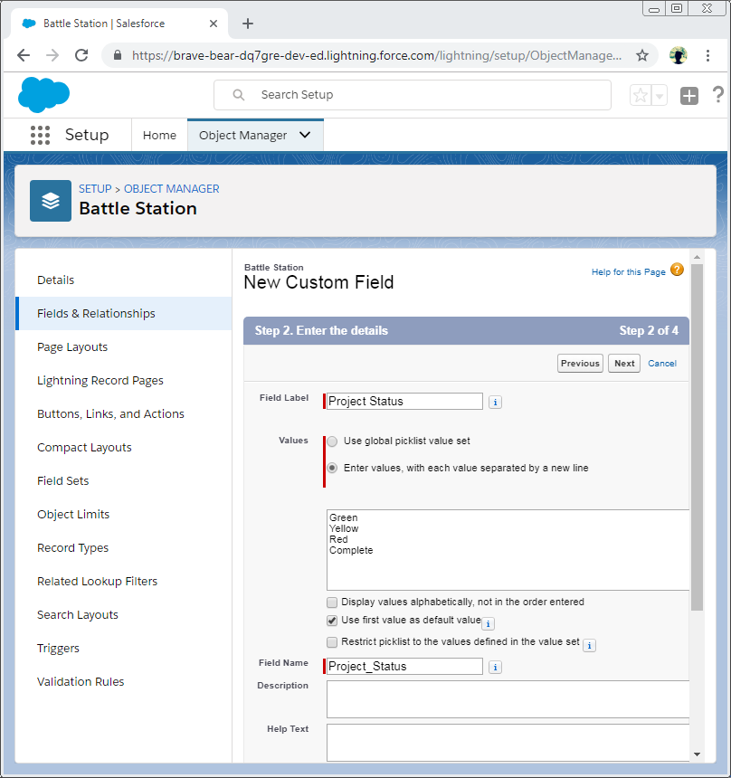

* Set Field Label as Project Status , Check radio button next to Enter values, with each value separated by a new line.
* Now Enter the values as of the above diagram and leave the Use first value as default as checked and remaining as unchecked.
* Click Next-> Next-> Save& New

1. **Add a Weapon Status field**

* Similar to the Project Status field select Picklist-> click Next.
* Enter the Field Label as Weapon Status ,Check radio button next to Enter values,with each value separated by a new line.

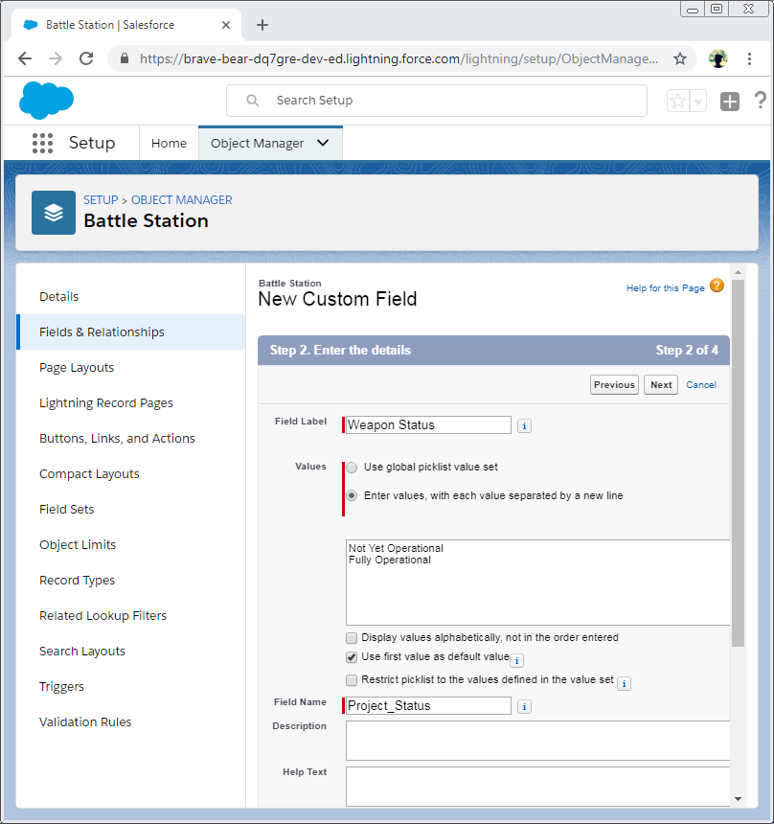

* Now check the Use first values as default value and leave the remaining as unchecked.
* Click Next -> Next->Save

**Resource Custom Object**

* When building a Battle Station you have to have resources to do the actual work
* On the Playground click **Object Manager** -> click on **Create Dropdown** and then select **custom Object**.Create the Object as follows :

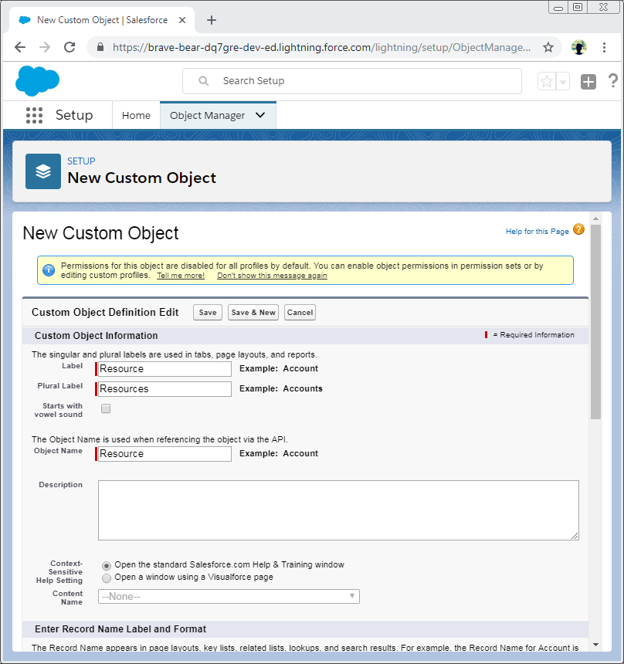

* Now Check Allow Reports at the bottom and Save.
* Create Custom tab Click Home tab -> Enter Tabs in Quick Find ->Select Tabs.
* Under Custom Object Tabs -> Click New.
* Select Resource as Object and choose any icon for the Tab style and leave the defaults as it is and save.

1. **Add a Quantity field**

* Create Quantity field - > Select Number and click Next .

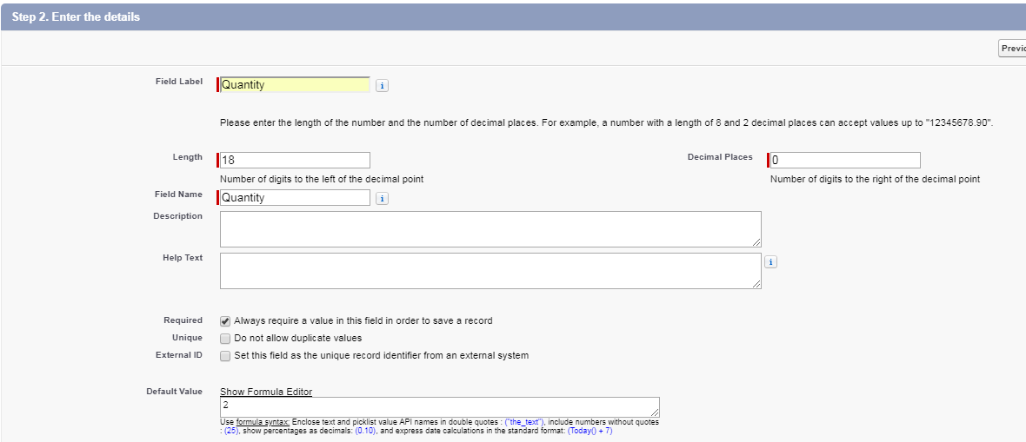

* Leave the defaults for the remaining fields, and click Next.
* Click **Next** again to accept the default field visibility and security settings.
* Click **Save & New** to add the Quantity field to the page layout, save the Quantity field, and return to the first step of the wizard.

**2: Add a Utilization field**

* Create the **Utilization** field as follows:
* For Data Type, select **Percent**, and click **Next**.

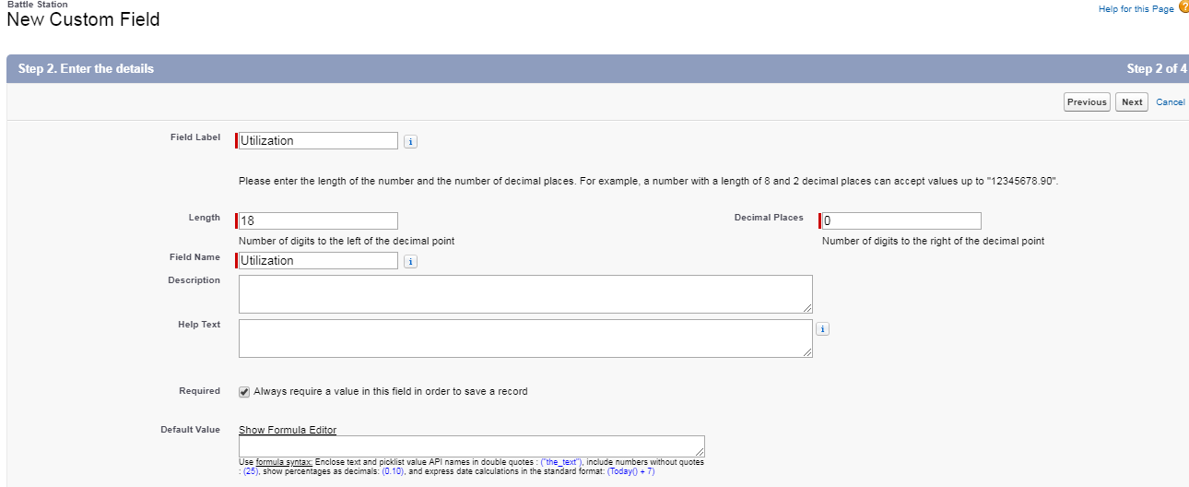

* Leave the defaults for the remaining fields, and click **Next**.
* Click **Next** again to accept the default field visibility and security settings.
* Click **Save & New** to add the Utilization field to the page layout, save the Utilization field, and return to the first step of the wizard.

3. **Add a Battle Station field (Master-Detail Relationship)**

* Create the **Battle Station** relationship field as follows:
* For Data Type, select **Master-Detail Relationship**, and click **Next**.
* Select **Battle Station** from the Related To picklist, and click **Next**.
* 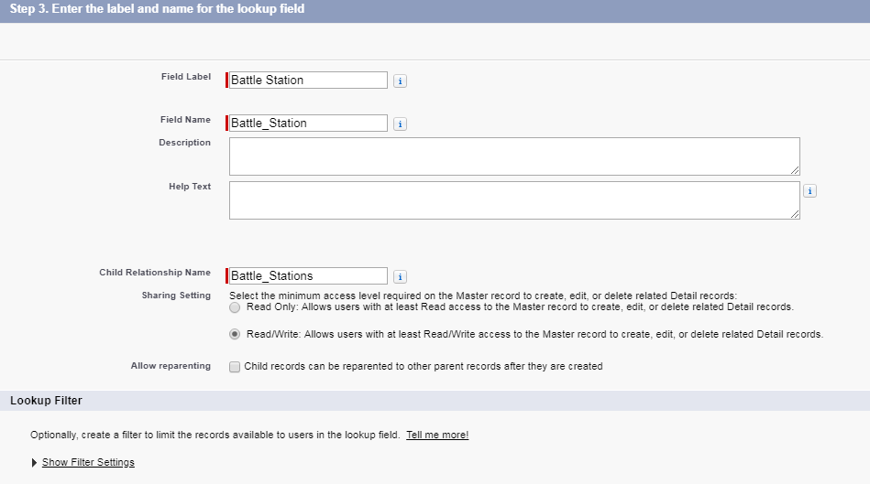Leave the defaults for the remaining fields, and click **Next**.
* Click **Next** again to accept the default field visibility and security settings.
* Click **Next** to add the Battle Station field to the page layout.
* Click **Save** to add the Battle Station field to the page layout, the related list of Battle Station records to the page layout (we'll go into more detail in a second), save the Battle Station field, and return to the Resource Custom Object page.

**Supplies Custom Object**

* To get back to Object Manager, click setting.png and select **Setup**. Click on **Object Manager** tab next to Home. Click the **Create** dropdown -> select Custom Object again to get started. On the Custom Object Definition page, create the object as follows:

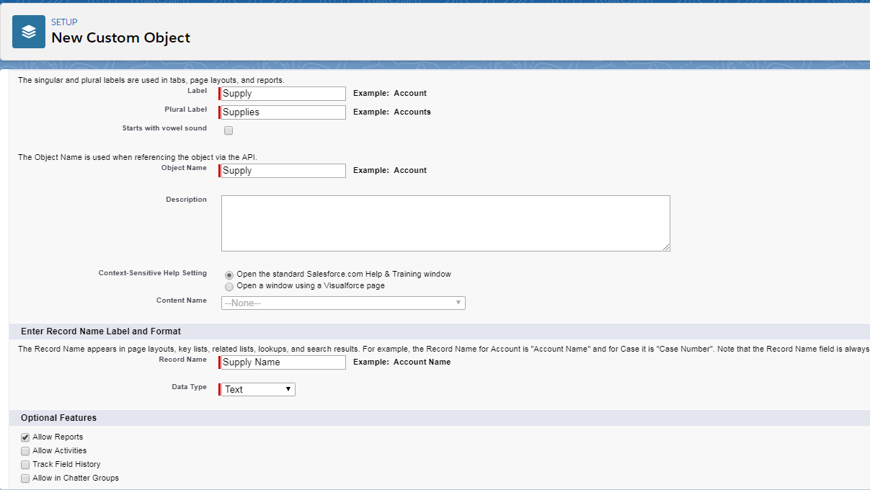

* Click **Save**.
* Now create a custom tab. Click the Home tab, enter Tabs in Quick Find and select **Tabs**.
* Under **Custom Object Tabs**, click **New**.
* For **Object**, select **Supply**.
* For **Tab Style**, select any icon.
* Leave all defaults as is. Click **Next, Next**, and **Save**.

1: **Add a Quantity field**

* When we order light bulbs or armor wax, we need to track the quantity.
* Create the **Quantity** field as follows:
* For Data Type, select **Number**, and click **Next**. And enter the following values:



* We want to encourage our users to order at least 2 of any supply (we always like to have a back up), so we'll set the **default value** to **2**.
* Leave the defaults for the remaining fields, and click **Next**.
* Click **Next** again to accept the default field visibility and security settings.
* Click **Save & New** to add the Quantity field to the page layout, save the Quantity field, and return to the first step of the wizard.

2. **Add a Unit Cost field**

* Create the **Unit Cost** field as follows:
* For Data Type, select **Currency**, and click **Next**.
* Fill in the custom field details:

Field Label: Unit Cost

Length: 16

Decimal Places: 2

* Ensure that there is always a number entered for this field by checking the **Required** checkbox.
* Leave the defaults for the remaining fields, and click **Next**.
* Click **Next** again to accept the default field visibility and security settings.
* Click **Save & New** to add the Unit Cost field to the page layout, save the Unit Cost field, and return to the first step of the wizard.

3: **Add a Total Cost field (Formula Field)**

* Create the **Total Cost** formula field as follows:
* For Data Type, select **Formula**, and click **Next**.
* Fill in the custom field details:

**Field Label**: Total Cost

**Field Name**: Total_Cost

Formula Return Type: **Currency**

Decimal Places: 2

Click **Next**.

* Since we want to see the total cost for each supply record, enter the following for the **formula**: Quantity__c * Unit_Cost__c, and click **Next**.
* Click **Next** again to accept the default field visibility and security settings.
* Click **Save & New** to add the Total Cost field to the page layout, save the Total Cost field, and return to the first step of the wizard.

**4.Add a Battle Station field (Master-Detail Relationship**

* Create the **Battle Station** relationship field as follows:
* For Data Type, select **Master-Detail Relationship**, and click **Next**.
* Select **Battle Station** from the Related To picklist, and click **Next**.

**Field Label**: Should default to **Battle Station**

**Field Name**: Battle_Station

* Leave the defaults for the remaining fields, and click **Next**.
* Click **Next** again to accept the default field visibility and security settings.
* Click **Next** to add the Battle Station field to the page layout.
* Click **Save** to add the Battle Station field to the page layout, the related list of Battle Station records to the page layout and save the Battle Station field, and return to the Supply Custom Object page.
* Now Verify the process by clicking on the verify button .

You can see the list of the fields and all in the Fields and Relationships dashboard as follows :

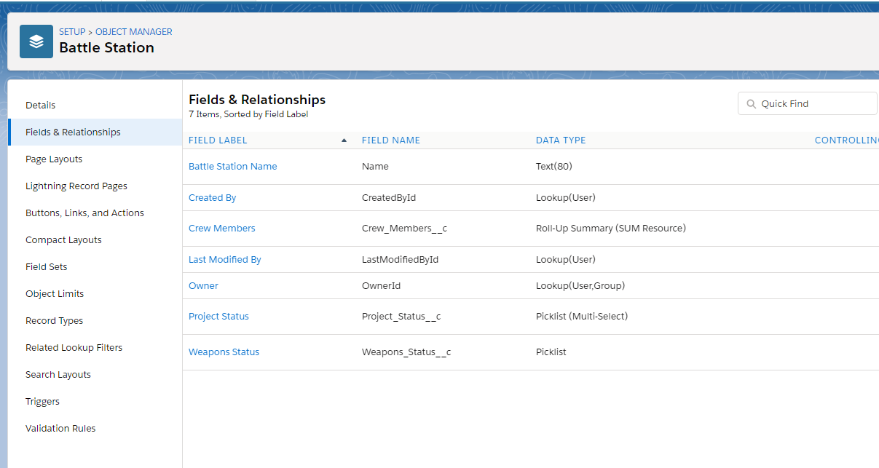

**RESULT** : Thus Creation of the Object Model is done Successfully in Battle Station App.